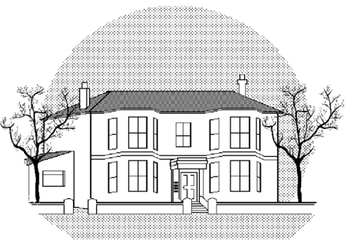

Selden Medical Centre
Patient Participation Group
Meeting Minutes Thursday April 2018

Attendees- Jeremy Ellis, Nancy Bell, Rita Lintern, Barbara Little, Mark Hughes, Tony Smith, Shaun Lyons (Chair)
Apologies- Keith Bickers, Rosie Gray, Trevor Gray, Mascha Richards, Barry Richards, Ron Allen, Patricia Allen, Roger Morton

- Minutes of last meeting

SL reiterated the QOF scores year on year and how the Practice has improved on 17/18 figures, these also included C Screening and Childhood Vaccines uptake

2)
- CQC Visit. SL informed the PPG that the next CQC visit was expected to take place in the coming weeks. The Practice has worked very hard in the last 6 months to improve the rating of ‘Requires Improvement’. NHS Choices and Google reviews for the practice have all been very positive as have I Want Great Care and Friends & Family. Patients have also been very responsive to the changes made to the surgery upon attending and have noticed the improvements made.

3)
- New telephone message As per last PPG this has now been changed. Feedback from patients is that the new system is far easier to navigate
4)

- Staff Update SL Informed the PPG that attempts to recruit a full time summariser for the Practice were unsuccessful and we are now training an existing member of staff to assist with our current summariser. We are also training a reception member in to perform secretarial duties as a contingency
5)

PPG Response to changes

Positives
PPG members report they definitely feel more positive about the surgery although some are not particularly enamoured with the new colour scheme(!) QOF increase achievements are recognised.

Negatives
Members report that it is still difficult to get through to the surgery via the telephone first thing in the morning. SL will look into

6) How can we improve the Selden Website

SL Proposes Selden website needs improving and asks PPG for thoughts/input. https://www.seldenmedicalcentre.nhs.uk/Home To be discussed at next meeting

7) Flu Campaign for 2019/20, How can the PPG Assist

SL asked how the PPG could assist with the 2019/20 flu campaign, raising awareness etc. To be discussed at next meeting

